**Project Design Phase**

**Problem – Solution Fit Template**

|  |  |
| --- | --- |
| Date | 15 February 2025 |
| Team ID | LTVIP2025TMID37691 |
| Project Name | Sustainable Smart City Assistant using IBM Granite LLM |
| Maximum Marks | 2 Marks |

**Problem – Solution Fit Template:**

The Problem-Solution Fit simply means that you have found a problem with your customer and that the solution you have realized for it actually solves the customer’s problem. It helps entrepreneurs, marketers and corporate innovators identify behavioral patterns and recognize what would work and why

**Purpose:**

|  |  |
| --- | --- |
| ❑ | Solve complex problems in a way that fits the state of your customers. |
| ❑ | Succeed faster and increase your solution adoption by tapping into existing mediums and channels of behavior. |
| ❑ | Sharpen your communication and marketing strategy with the right triggers and messaging. |
| ❑ | Increase touch-points with your company by finding the right problem-behavior fit and building trust by solving frequent annoyances, or urgent or costly problems. |
| ❑ | **Understand the existing situation in order to improve it for your target group.** |

**Template:**

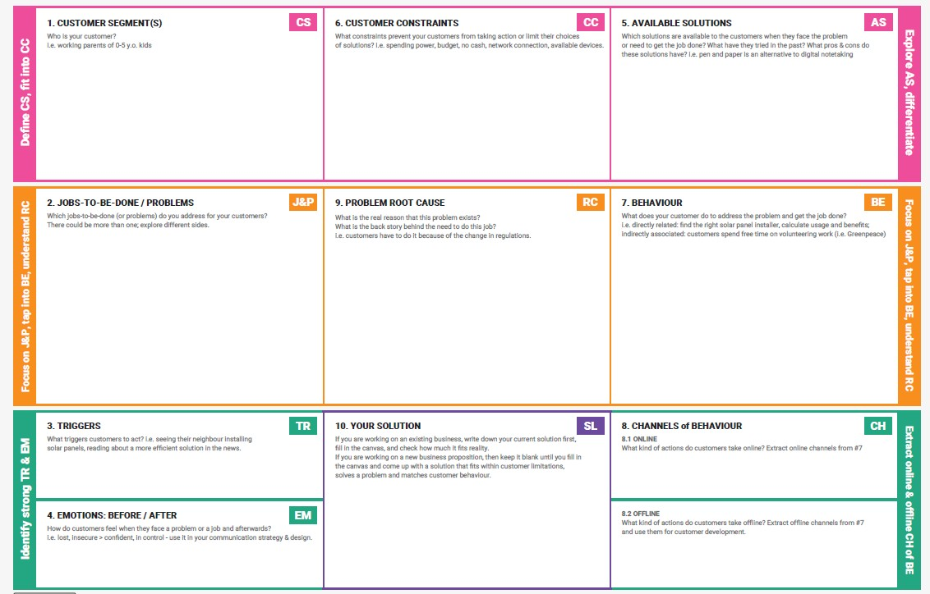

# Problem–Solution Fit Template

**1. CUSTOMER SEGMENT(S)**

City governments, urban planners, sustainability officers, and engaged citizens.

## 2. JOBS-TO-BE-DONE / PROBLEMS

* Make informed sustainability decisions using real-time urban data.
* Engage citizens effectively in eco-friendly behaviors.
* Summarize and act on complex city policies efficiently.
* Detect anomalies and forecast urban trends (e.g. pollution, energy consumption).

## 3. TRIGGERS

* New city sustainability regulations.
* Public demand for smart, green urban environments. • Pressure to digitize city operations.
* Media attention on climate crises or tech innovations

## 4. EMOTIONS: BEFORE / AFTER

**Before**: Frustrated, disconnected, overwhelmed with fragmented data.

**After**: Empowered, informed, connected, optimistic about urban sustainability.

## 5. AVAILABLE SOLUTIONS

* Manual monitoring and fragmented dashboards.
* Basic IoT-based city management platforms.
* Static government websites or helplines.

**Cons**: Not personalized, no AI capabilities, poor citizen interaction, limited insights.

## 6. CUSTOMER CONSTRAINTS

* Limited budget (especially in smaller cities).
* Lack of AI expertise in city staff.
* Resistance to adopting new technologies.
* Concerns over data privacy and infrastructure compatibility.

## 7. BEHAVIOUR

**Direct**:

* Use city dashboards to analyze data manually.
* Read policies, reports, and forecasts individually. **Indirect**:
* Participate in community meetings, public feedback forums.

## 8. CHANNELS of BEHAVIOUR

### 8.1 ONLINE

* Search for city updates, policy summaries.
* Access dashboards and reports.
* Use mobile apps or websites for alerts and tips.

### 8.2 OFFLINE

* Attend town halls or city planning sessions.
* Read flyers or public notices.
* Talk to community leaders.

## 9. PROBLEM ROOT CAUSE

City operations are often siloed with disparate systems and poor citizen integration. The real driver is the complexity of managing sustainability at scale without a unified intelligent interface.

## 10. YOUR SOLUTION

An AI-powered Sustainable Smart City Assistant built on IBM Granite LLM that:

* Integrates real-time IoT and urban data.
* Summarizes policies, detects anomalies, and forecasts trends.
* Provides natural language responses and eco-advice.
* Offers freemium access for cities, with premium insights for partners